**Day 1:**

**Assignment 2: Draw your Home Network Topology and explain how you are accessing the RPS Lab environment**.

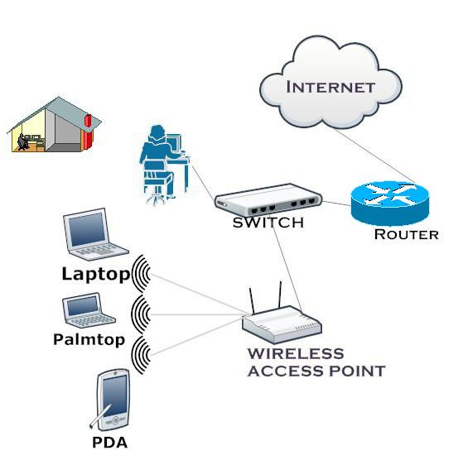

1. **Internet**: The starting point is the internet, which provides access to the global network of networks.
2. **Modem**: The modem connects to your Internet Service Provider (ISP) and converts the internet signal into a form that your home network can use.
3. **Router**: The router connects to the modem and directs traffic between the modem and the various devices in your home. It creates your home network, both wired and wireless.
4. **Devices**: Various devices in your home connect to the router. This includes:
   * **Smartphone**: Connects wirelessly to the router.
   * **Laptop**: Connects wirelessly to the router.
   * **Desktop Computer**: Usually connects to the router via an Ethernet cable for a stable connection.
   * **Smart TV**: Can connect wirelessly or via an Ethernet cable.
   * **Printer**: Can connect wirelessly or via an Ethernet cable.
   * **RPS Lab Computer**: A computer dedicated to accessing the RPS Lab environment, usually connected via Ethernet for a stable and fast connection.

### Accessing the RPS Lab Environment

To access the RPS Lab environment from your home network, you would typically follow these steps:

1. **Connect to the Internet**: Ensure your device (laptop, desktop, etc.) is connected to the home network via the router.
2. **VPN (Virtual Private Network)**: Many labs require a secure connection. You might need to use a VPN to securely connect to the RPS Lab network. The VPN will create a secure tunnel from your device to the lab's network.
3. **Remote Desktop Software**: Use software like Remote Desktop Protocol (RDP), VNC, or other remote access tools to connect to the specific computer or server in the RPS Lab. This software allows you to control the lab computer as if you were sitting right in front of it.
4. **Login Credentials**: Enter your lab credentials (username and password) to access the resources within the RPS Lab environment.